RFID-BASED SMART ATTENDANCE

SYSTEM

Submitted by-
SATYAM PRAJAPATI – 2025041260
SHASHIKANT DWIVEDI – 2025041261
SARANG GOPALAN – 2025041259
NIKHIL KUMAR – 2025041241
SUBHASH SINGH - 2025041264
Department of
Electronics and Communication Engineering
Madan Mohan Malaviya University of Technology, Gorakhpur (U.P.)
INDIA
March-April, 2026

CANDIDATE DECLARATION
SATYAM PRAJAPATI – 2025041260
SHASHIKANT DWIVEDI – 2025041261
SARANG GOPALAN – 2025041259
NIKHIL KUMAR – 2025041241
SUBHASH SINGH - 2025041264

I declare that the written work and ideas are in our own words while other ideas or words included have been adequately cited and reference the original sources. We also declare that we have adhered to all principle of academic honesty and integrity and have not misrepresented or fabricated or falsified any idea/data/fact/source in our submission. We understand that any violation of the above will be cause for disciplinary action by the University and can also evoke penal action from the sources which have thus not been properly cited or from whom proper permission has not been taken when needed.
Department of Electronics & Communication Engineering
(Design Thinking and Innovation)

Date: ________

APPROVAL SHEET
The Project report titled RFID BASED SMART ATTENDANCE SYSTEM is approved as the project for the subject BEC-170 Design Thinking and Innovation

Subject Teacher:
Mr. Tushant Kumar Sir
Department of Electronics and Communication Engineering
_____________________

Subject Coordinator:
Dr. B.P. PANDEY Sir
Department of Electronics and Communication Engineering
_____________________

Date: _________
Place: M.M.M.U.T, Gorakhpur
📑 TABLE OF CONTENTS (FOR YOUR PROJECT)

CHAPTER 1: INTRODUCTION ............................................... 6
• 1.1 Overview of Smart Systems and IoT .................................. 6
• 1.2 Introduction to RFID Technology (RC522) .......................... 6
• 1.3 Motivation ................................................................. 6
• 1.4 Problem Statement ...................................................... 6
• 1.5 Objectives ................................................................. 7

CHAPTER 2: LITERATURE REVIEW .................................. 8
• 2.1 Evolution of Attendance Systems .................................. 8
• 2.2 RFID Technology in Attendance Systems ..................... 8
• 2.3 Microcontroller Platforms: ESP32 vs Arduino .............. 8
• 2.4 Web-Based Attendance Systems ................................. 8
• 2.5 Comparison of Technologies (RFID, QR, Biometric) .... 8

CHAPTER 3: METHODOLOGY AND TECHNICAL DETAILS .... 9
• 3.1 System Architecture Overview ..................................... 9
• 3.2 Hardware Components and Interfacing (ESP32 + RC522) ... 9
• 3.3 Software Stack and Development Tools ....................... 9
• 3.4 Working Principle of the System ................................. 10
• 3.5 Flowchart Explanation .................................................. 10

CHAPTER 4: IMPLEMENTATION AND RESULTS ................. 11
• 4.1 RFID Attendance Working Process .............................. 11
• 4.2 Web Dashboard Design (Student + Faculty) ............... 11
• 4.3 Database Integration and Real-Time Updates ............ 11
• 4.4 Output Screens and System Testing ............................ 12

CHAPTER 5: ADVANTAGES AND LIMITATIONS ................. 13
• 5.1 Advantages of the System .......................................... 13
• 5.2 Limitations and Challenges ........................................ 13

CHAPTER 6: FUTURE SCOPE .............................................. 14
• 6.1 QR Code-Based Lecture Attendance System ............. 14
• 6.2 Mobile Application Integration .................................... 14
• 6.3 Cloud and AI-Based Analytics ..................................... 15

CHAPTER 7: CONCLUSION ................................................. 16
• 7.1 Project Summary ........................................................ 16
• 7.2 Final Remarks .........................................................
REFERENCES ................................................................. 17
📘 CHAPTER 1: INTRODUCTION
1.1 Overview of Smart Systems and IoT
In recent years, the concept of smart systems has gained significant importance due to advancements in the Internet of Things (IoT). IoT refers to a network of interconnected devices that communicate and exchange data over the internet without human intervention. In the education sector, IoT enables automation of routine processes such as attendance tracking, classroom monitoring, and resource management.
Traditional attendance systems rely on manual methods, which are time-consuming and prone to errors. Smart attendance systems utilize IoT devices such as microcontrollers, sensors, and wireless communication modules to automate the process. These systems not only save time but also improve accuracy and provide real-time data access.
1.2 Introduction to RFID Technology (RC522)
Radio Frequency Identification (RFID) is a wireless technology used for automatic identification and tracking of objects using radio waves. It consists of two main components: RFID tags and RFID readers. Each RFID tag contains a unique identification number (UID) that can be read by the RFID reader.
In this project, the RC522 RFID module is used, which operates at 13.56 MHz frequency. It is widely used due to its low cost, reliability, and compatibility with microcontrollers like ESP32. When a student brings their RFID card near the reader, the UID is detected and processed by the system to mark attendance.
1.3 Motivation
The motivation behind this project arises from the limitations of traditional attendance systems. Manual attendance takes significant time during lectures and is prone to human errors. Additionally, proxy attendance is a common issue where students mark attendance on behalf of others.
This project aims to develop a system that automates attendance marking, ensures transparency, and reduces fraudulent practices. The integration of RFID and web technologies provides a modern solution that is efficient and scalable.
1.4 Problem Statement
Traditional attendance systems lack efficiency, accuracy, and real-time accessibility. They require manual effort, which leads to time wastage and possible errors. Furthermore, there is no centralized system for monitoring attendance data.The problem addressed in this project is to design a system that automates attendance marking, stores data securely, and provides real-time access to both faculty and students.
1.5 Objectives
The main objectives of this project are:
- To develop an RFID-based attendance system using ESP32
- To automate attendance marking using RFID cards
- To create a web dashboard for monitoring attendance
- To provide access to both students and faculty
- To ensure real-time data storage and retrieval
- To plan future enhancements like QR-based attendance

📚 CHAPTER 2: LITERATURE REVIEW
2.1 Evolution of Attendance Systems
Attendance systems have evolved from manual registers to digital solutions. Initially, attendance was recorded manually, which was inefficient. Later, biometric systems were introduced, offering better accuracy but at higher cost. RFID systems emerged as a balance between cost and efficiency.
2.2 RFID Technology in Attendance Systems
RFID technology is widely used in attendance systems due to its contactless nature and speed. It allows quick identification and reduces time consumption. Many institutions have adopted RFID-based systems for improved efficiency.
2.3 Microcontroller Platforms: ESP32 vs Arduino
Microcontrollers play a crucial role in IoT systems. Arduino is easy to use but lacks built-in WiFi. ESP32, on the other hand, provides WiFi and Bluetooth capabilities, making it ideal for real-time data transmission. Therefore, ESP32 is preferred in this project.
2.4 Web-Based Attendance Systems
Web-based systems allow centralized storage and easy access to data. They enable students to view their attendance and faculty to manage records efficiently. Technologies like Firebase and web frameworks are commonly used.
2.5 Comparison of Technologies
RFID systems are fast and cost-effective but require cards. Biometric systems are accurate but expensive. QR-based systems are flexible but depend on mobile devices. Each technology has its advantages and limitations.

⚙️ CHAPTER 3: METHODOLOGY AND TECHNICAL DETAILS
3.1 System Architecture Overview
The system consists of hardware and software components working together. The RFID reader captures the UID of the card and sends it to the ESP32. The ESP32 processes the data and sends it to the web server using WiFi. The server stores the data in a database and displays it on the dashboard.
3.2 Hardware Components and Interfacing (ESP32 + RC522)
The hardware setup includes ESP32 and RC522 RFID module. The RC522 is connected to ESP32 using SPI communication. Power supply is provided through USB or external source. Proper wiring ensures accurate data transmission.
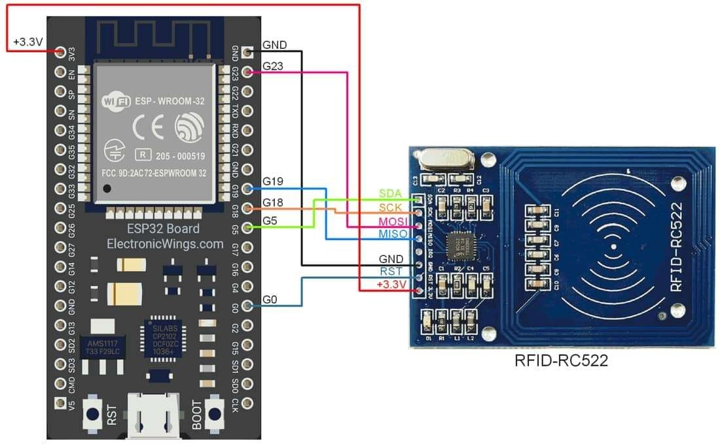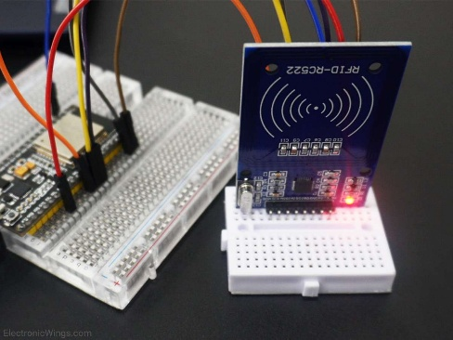
The above figure shows the interfacing of the RC522 RFID module with the ESP32 microcontroller using SPI communication. Proper connections ensure accurate data transmission and system performance.
3.3 Software Stack and Development Tools
The system is developed using:
- Arduino IDE for ESP32 programming
- HTML, CSS, JavaScript for frontend
- Firebase or database for backend
- APIs for communication
3.4 Working Principle of the System
When a student scans the RFID card:
- RC522 reads UID
- ESP32 processes UID
- Data sent to server via WiFi
- Server verifies student
- Attendance is marked
- Data displayed on web dashboard
3.5 Flowchart Explanation
The flowchart represents the working of the system. It starts with scanning the RFID card, followed by data verification. If the UID matches, attendance is recorded; otherwise, it is rejected.
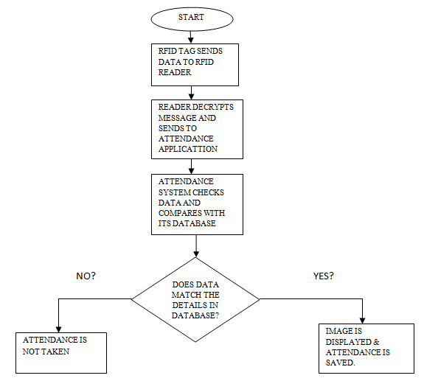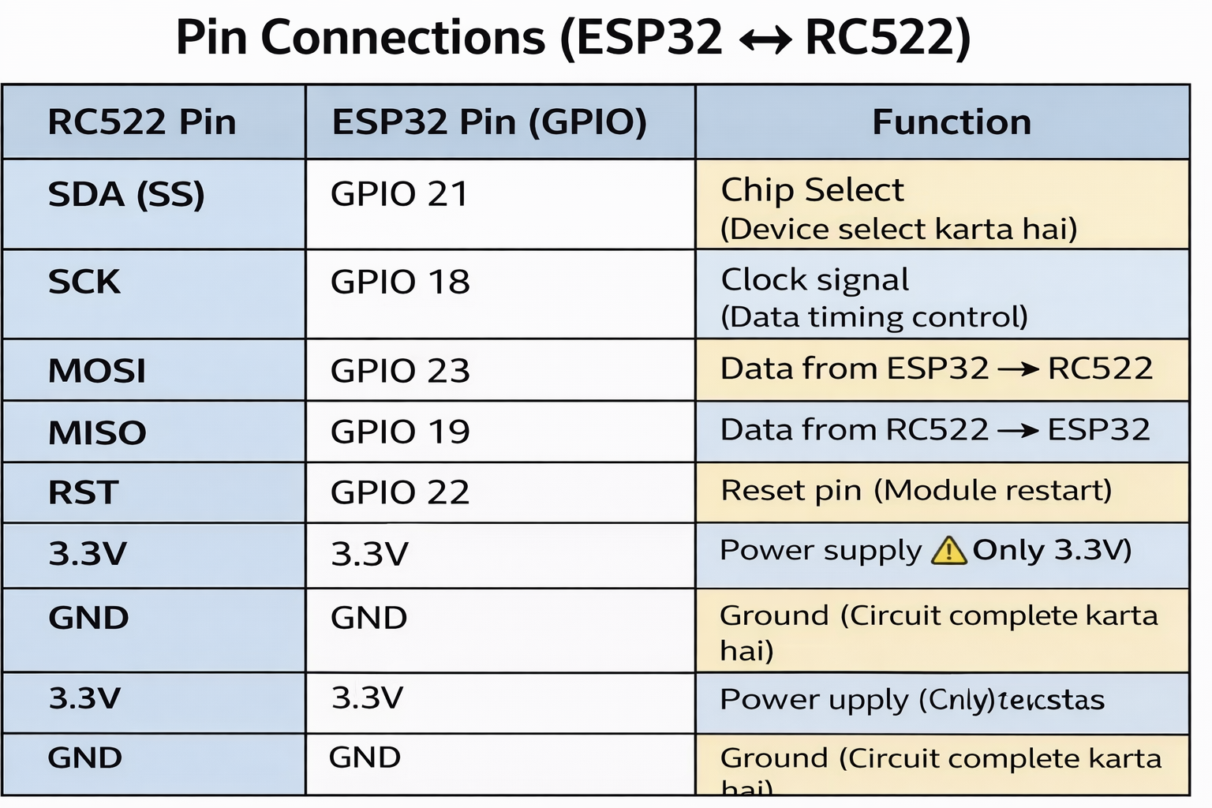
🚀 CHAPTER 4: IMPLEMENTATION AND RESULTS
4.1 RFID Attendance Working Process
The system successfully reads RFID cards and marks attendance instantly. The process is fast and reliable.
4.2 Web Dashboard Design (Student + Faculty)
The web dashboard provides separate interfaces for students and faculty. Students can view attendance, while faculty can manage records.
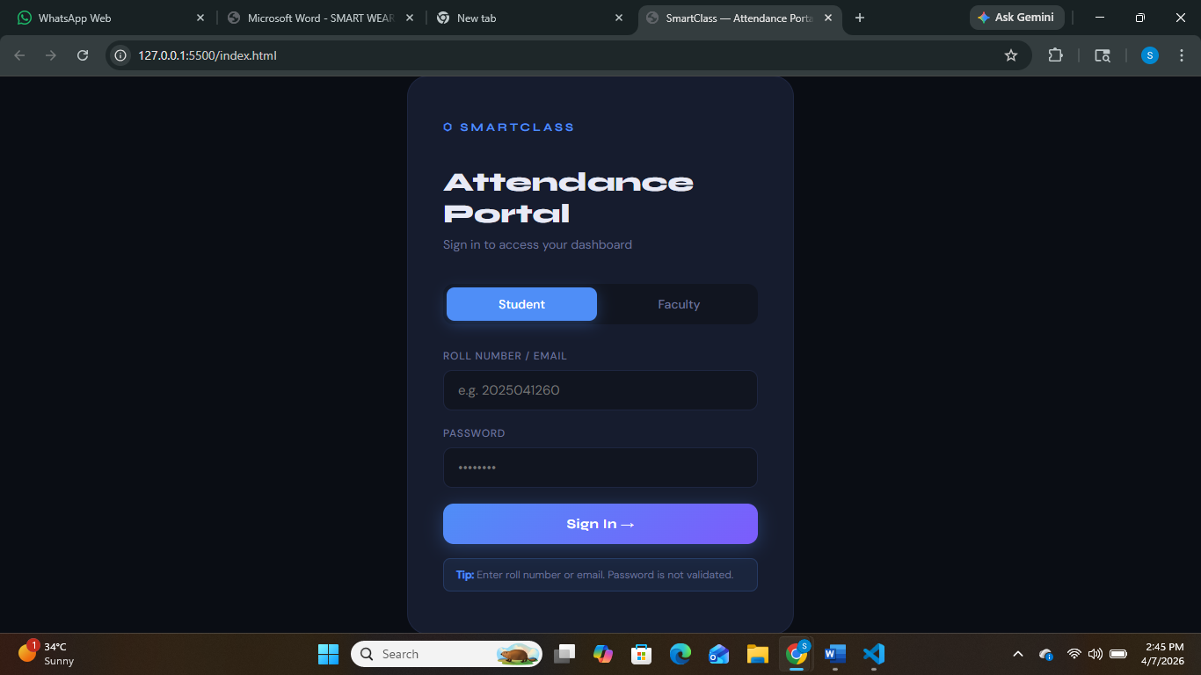
4.3 Database Integration and Real-Time Updates
The database stores attendance records securely. Updates are reflected in real-time, ensuring data accuracy.
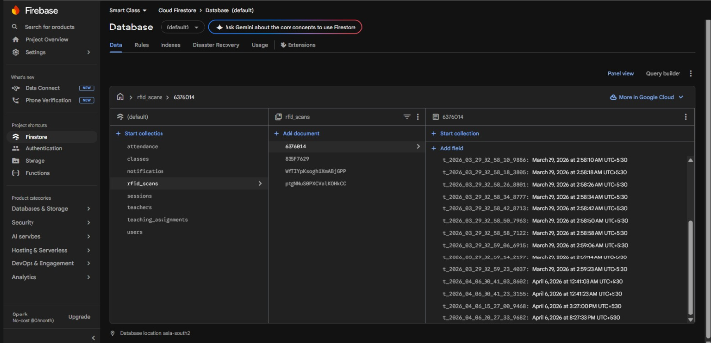

4.4 Output Screens and System Testing
The system was tested with multiple users and showed accurate results. Screenshots of the dashboard demonstrate functionality.
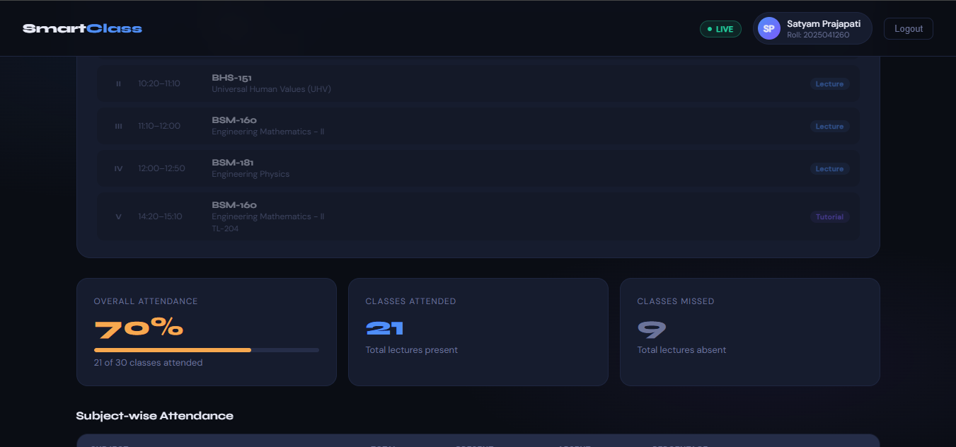

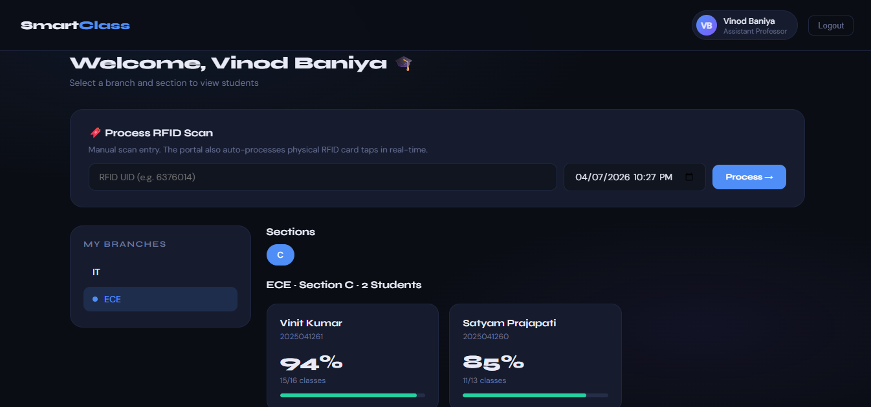

⚖️ CHAPTER 5: ADVANTAGES AND LIMITATIONS
5.1 Advantages of the System
The proposed RFID-based smart attendance system offers several advantages over traditional attendance methods. One of the major benefits is automation, which eliminates the need for manual attendance marking and saves valuable classroom time.
Another key advantage is accuracy and reliability. Since each RFID card has a unique identification number, errors in attendance recording are minimized and data is stored securely.
The system also provides real-time data access through a web dashboard, allowing both students and faculty to monitor attendance easily. This improves transparency and reduces disputes.
Additionally, the system is cost-effective and scalable, as components like ESP32 and RC522 are affordable and suitable for large-scale implementation.

5.2 Limitations and Challenges
Despite its advantages, the system has certain limitations. One major limitation is dependency on RFID cards, as attendance cannot be marked if the card is lost or forgotten.
Another issue is proxy attendance through card sharing, which may reduce system reliability.
The system also depends on internet connectivity, and any network failure can temporarily disrupt attendance recording.
Additionally, proper hardware setup and configuration require technical knowledge, and the system has limited security features in its basic version.

🔮 CHAPTER 6: FUTURE SCOPE
6.1 QR Code-Based Lecture Attendance System
In the future, the system can be enhanced by integrating a QR code-based attendance system. Instead of using RFID cards, each lecture can generate a unique QR code. Students can scan this code using their mobile phones to mark attendance.
This approach eliminates the need for physical cards and reduces the chances of proxy attendance. Since the QR code can be time-limited, it ensures that only students present in the class can mark attendance.

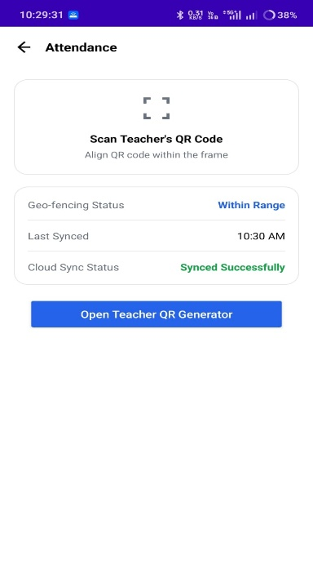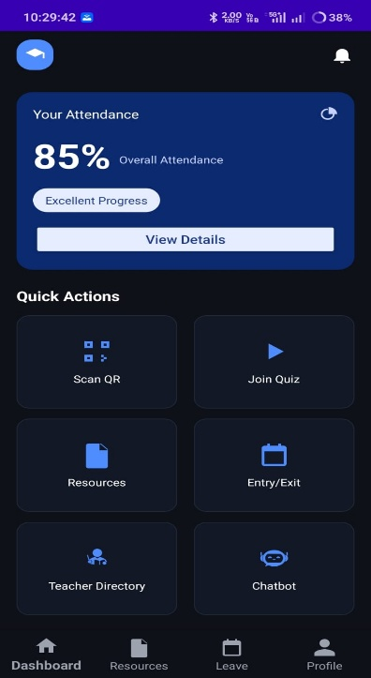

6.2 Mobile Application Integration
Another major improvement is the development of a mobile application for the system. The mobile app can provide features such as:
- Viewing attendance records
- Receiving notifications for low attendance
- Scanning QR codes for attendance
- Accessing timetable and updates
A mobile application enhances accessibility and provides a more user-friendly interface compared to web-only systems.

6.3 Cloud and AI-Based Analytics
The system can be further improved by integrating cloud computing and artificial intelligence (AI). Cloud integration will allow secure and scalable storage of attendance data.
AI-based analytics can be used to:
- Predict student attendance trends
- Identify students with low attendance
- Generate automated reports
- Provide insights for faculty decision-making
This will transform the system into an intelligent attendance management platform.

✅ CHAPTER 7: CONCLUSION
7.1 Project Summary
The RFID-based smart attendance system developed in this project provides an efficient and automated solution to traditional attendance methods. By integrating RFID technology with ESP32 and a web-based dashboard, the system ensures real-time attendance tracking and easy accessibility for both students and faculty.
The system successfully eliminates manual errors, reduces time consumption, and improves transparency in attendance management. The use of low-cost hardware components makes the system affordable and practical for real-world implementation.

7.2 Final Remarks
In conclusion, the project demonstrates how modern technologies like IoT and web development can be used to solve real-world problems effectively. Although the system has certain limitations, it provides a strong foundation for further enhancements.
With future improvements such as QR-based attendance, mobile applications, and AI integration, the system can evolve into a fully smart and intelligent attendance solution. This project highlights the potential of combining hardware and software technologies to create impactful applications in the education sector.

📖 REFERENCES
[1] NXP Semiconductors, “MFRC522 Standard Performance MIFARE Reader IC,” [Online]. Available: https://www.nxp.com/docs/en/data-sheet/MFRC522.pdf. [Accessed: March 2026].
[2] Espressif Systems, “ESP32-WROOM-32 Datasheet,” [Online]. Available: https://www.espressif.com/sites/default/files/documentation/esp32-wroom-32_datasheet_en.pdf. [Accessed: March 2026].
[3] Arduino, “Arduino IDE Documentation,” [Online]. Available: https://www.arduino.cc/en/software. [Accessed: March 2026].
[4] Random Nerd Tutorials, “ESP32 with MFRC522 RFID Reader using Arduino IDE,” [Online]. Available: https://randomnerdtutorials.com/esp32-mfrc522-rfid-reader-arduino/. [Accessed: March 2026].
[5] Firebase by Google, “Firebase Realtime Database Documentation,” [Online]. Available: https://firebase.google.com/docs/database. [Accessed: March 2026].
[6] MDN Web Docs, “HTML, CSS, and JavaScript Documentation,” [Online]. Available: https://developer.mozilla.org/. [Accessed: March 2026].
[7] IEEE, K. Patel and M. Shah, “RFID-Based Smart Attendance System,” International Journal of Engineering Research & Technology (IJERT), vol. 5, no. 3, pp. 112–115, 2016.
[8] IJERT, S. Kumar and R. Singh, “IoT Based Smart Attendance Management System Using RFID,” IJERT, vol. 8, no. 6, pp. 45–49, 2019.
[9] Elsevier, A. K. Jain et al., “Biometric vs RFID Systems in Attendance Management,” Procedia Computer Science, vol. 85, pp. 272–279, 2016.
[10] ResearchGate, M. Gupta and P. Verma, “Web-Based Attendance System Using IoT,” [Online]. Available: https://www.researchgate.net/. [Accessed: March 2026].

